Friday  October 3rd, 2025 | Viking Times

Anukriti Eswaramoorthy  What Is Happening at Northwest High?  “Show Your School Spirit!”  A school’s Spirit Week serves as an opportunity for students and educators to cultivate a sense of community and pride through themed dress-up days designed to showcase school spirit. This year’s Spirit Week at Northwest High School (NWHS) in 2025 was particularly notable, as students demonstrated impressive engagement and enthusiasm throughout the event. Note: This Spirit Week was from September 15 to September 19, 2025.  On “Dress Like Your Type” day, students embraced creativity by donning attire that humorously contrasted traditional gender norms, with boys sporting traditionally feminine outfits and girls selecting outfits typically associated with boys. This year, participation exceeded expectations, reflecting a strong commitment to school spirit.  The daily themes of Spirit Week were as follows: Monday was designated as “70s Day,” Tuesday was “Pajama Day,” Wednesday featured “Dress Like Your Type” day, Thursday was dedicated to the “Powderpuff Game,” and Friday culminated in “Show Your Spirit Day,” where Freshmen wore gray, Sophomores donned white, Juniors chose black, and Seniors showcased red. Each class actively contributed to the spirit of the week, culminating in a vibrant expression of pride in the school community. A school’s Spirit Week is a powerful opportunity for students and teachers to foster community and pride through engaging and themed dress-up days that celebrate school spirit. This year's Spirit Week at Northwest High School (NWHS) in 2025 was an outstanding success, with students demonstrating remarkable enthusiasm and creativity throughout the event.  On “Dress Like Your Type” day, students boldly embraced the theme by wearing outfits that playfully challenged traditional gender norms, with boys showcasing traditionally feminine attire and girls adopting styles typically associated with boys. The level of participation this year surpassed all expectations, reflecting a strong commitment to our school spirit.  The themes for each day of Spirit Week were as follows: Monday was “70s Day,” Tuesday was “Pajama Day,” Wednesday featured “Dress Like Your Type” day, Thursday was dedicated to the “Powderpuff Game,” and Friday culminated in “Show Your Spirit Day,” where Freshmen wore gray, Sophomores donned white, Juniors chose black, and Seniors showcased red. Each class actively contributed to the week’s vibrant atmosphere, culminating in an impressive display of school pride and unity. | 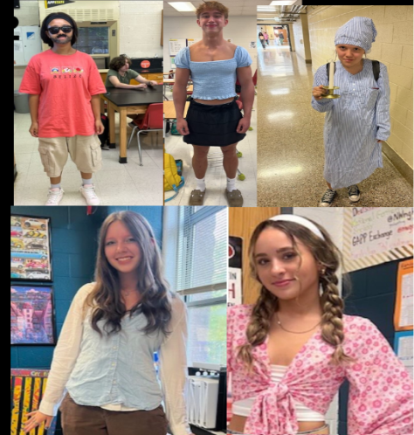  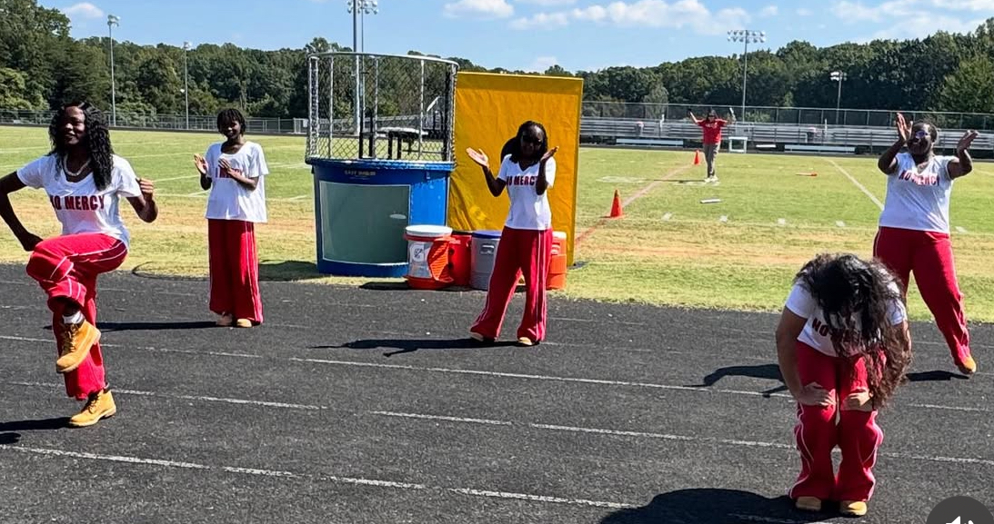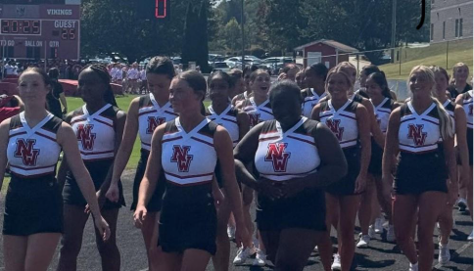

Anukriti Eswaramoorthy

Mr. Shelton Loves Spirit Week!
Mini Interview!

\

​​What did you think about our Spirit Week?
​“I think that Spirit Week was a fun way to kick off the school year! A lot was going on with the events, games, and the big dance, and I think the different days brought attention to all the events.”
​Did you enjoy participating in the Spirit Week?
“I was able to dress up for most of the days—I had a few meetings where I had to dress professionally, but I got to make up for those days by dressing down on pajama day and Adam Sandler day and being extra comfy.”
​What would you say about the student who participated and their spirits?
"I'm glad that so many students had the chance to let go of what others might think and just enjoy the few short years of high school by making memories with their friends. Goof off. Dive in. Get involved. Life is much more fun!"

Mr. Shelton is an English 1 honors teacher at Northwest. He has been in the community for two years now! He is bubbly, intellect and your typical favorite English teacher!

Friday October 3rd 2025 | Viking Times
Pranati Juturi

PEP RALLY! PEP RALLY!
WE LOVE SCHOOL SPIRIT!
The Pep Rally, held on September 19th, brought all the Northwest High School students
together in the football stadium. Seated on the firm bleachers, the students took a subtle glance
at the different group members from the various clubs, with a unique array of athletic and
performance teams that energized the school and its community. The cheerleading team, known
for its high spirit and unwavering support at games, walked in with great enthusiasm, followed
by the basketball, football, and volleyball teams, each known for their courageous and
outstanding matches against other schools, represents a sense of unity and teamwork, and
draws enthusiastic crowds to witness their magnificent games. The school’s dance team adds
an artistry touch to the PEP Rally, showcasing their courage and craftsmanship while performing
in front of the students. Other clubs and teams, ranging from Marching Band to other academic
and athletic groups, manifest diverse talents and the enthusiasm of the Vikings.

Once the demonstration came to an end, the teachers hosted
various activities which included
both students, from different grade levels, and teachers to participate in lively and entertaining
games such as “Musical Chairs”, or “Kick-the-football”.
“Pie-the-Teachers”, which was
subsequently held after the jovial games, included students volunteering to pie the teachers
they nominated, which, in this case, included paying money.
The event concluded with the activity “Dunk the teacher”
, where the students, once again,
volunteered to assist in the following activity, although, in the end, it was revealed that the
trigger malfunctioned, causing the teacher to jump into the water himself.
One of the freshmen stated, “It was really hot outside and the sun was burning my face, but the
games were quite good and we had lots of fun. I really liked the dance performance the best!”
Ranging from energetic performances, team presentations, and staff and students competitions
and participations, made the Pep Rally more than just an event. It turned out to be the
celebration of school spirit and unity, and more importantly, the Pep Rally turned the day
memorable and sparked excitement for what lies ahead in this school year.

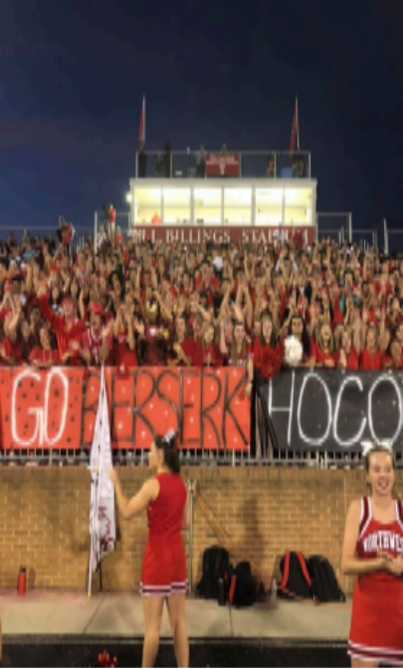

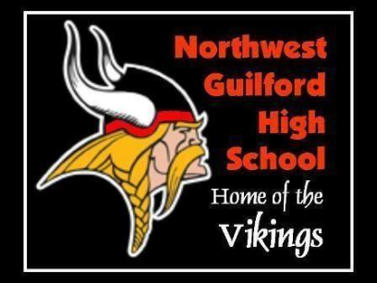
Pranati Juturi

Scoop Of The Month
Back To School!

” The only way to describe this event is “awesome and extraordinary”! This year’s Powderpuff game was the perfect culmination of an outstanding year, as the girls showcased their talent while the boys cheered them on. The event raised a significant amount of funds and served as an excellent kickoff for the Homecoming Dance, scheduled for Saturday, September 20, from 7 PM to 10 PM.”
-Anukriti Eswaramoorthy
Recently, Northwest High School held various sports events leading up to an exciting month of competition and celebration amongst the Vikings.
The following are the games held during September:
September 5th, Friday - Boys Varsity Football; NWHS vs NGHS (Winner) September 12th, Friday - Boys Varsity Football; RHSH vs NWHS (Winner) September 19th, Friday - Boys Varsity Football; NWHS vs MTHS (Winner) September 22nd, Monday - Girls Varsity Field hockey; NWHS vs Regan High School (Winner) September 23rd, Tuesday - girls JV volleyball; R.J. Reynolds High School vs NWHS (Winner)
And many more…
Many of the teams played with outright determination, focus, and energy, taking every step and playing with agility and absolute swiftness. Each team focused on winning and having a great time playing the match; some celebrated their victory, while others lost, giving their best efforts in the play. Although they lost, the respective teams won't surrender, and show the true meaning of what it means to be a true Viking in their next match; never give up!

Friday October 3rd 2025 | Outside The Building
Allister Aftab  Typhoon Ragsana  The latest updates |  | In the cities of Taiwan and Southern China, a raging typhoon has hit, causing millions to be evacuated. The violent storm is named Typhoon Ragasa is this year’s most powerful storm, causing severe flooding and damage with destructive winds reaching up to 150 mph. This storm has killed at least 20 people and injured at least 90, as it rages over many Southern Chinese cities.  Meanwhile, in Taiwan where the typhoon first struck, officials are describing it as “far worse than anticipated.” The storm has washed away several bridges, houses, and cars as residents attempt to escape from the chaos. Many of these residents became trapped on upper stories, awaiting rescue.  While Taiwan and Southern China have been majorly affected by Typhoon Ragasa, Hong Kong and the Philippines are also suffering the effects of the storm. This caused schools to be closed, businesses shut, flights to be grounded, and the Hong Kong Observatory to urge citizens to remain indoors. In the Philippines, at least 8 were killed in the floods the typhoon brought, while thousands were left displaced.  The Ministry of National Defense has deployed troops to assist in the rescue, but the time it will take to rescue and repair is unknown. The residents are left devastated, "I'm still in shock. I just can't imagine how this could have happened. This is one of the busiest areas in Hualien and the streets are lined with shops. We go to these places all the time but everything was destroyed yesterday," said 42-year-old Awa, a resident who runs a book shop with her husband. Many, including the couple, have sought refuge in an evacuation shelter, but the damage caused by the storm has left the people affected in grief.
Ragsana Typoon
TAKEN FROM
HERE

Sources:
https://www.bbc.com/news/articles/clyd580lx3mo
https://www.cnn.com/2025/09/23/asia/typhoon-ragasa-hong-kong-southern-china-impact-intl-hnk
https://www.nbcnews.com/world/asia/typhoon-ragasa-slams-hong-kong-killing-least-17-taiwan-philippines-rcna233352

